FCC FSL series Spiral Freezer parameter list
Model | Picture  (For reference) | Parameters
(Spiral)  FSL200 | 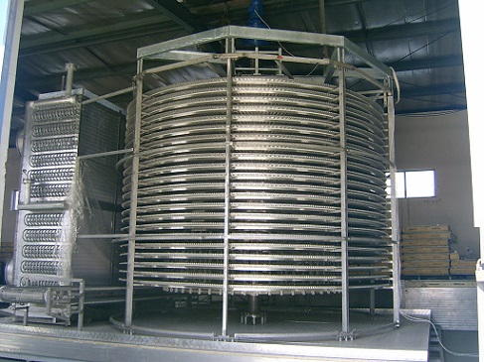 | Capacity : 200kg/h  Installed power: 3.55kw  Refrigeration Consumption: 32kw  Dimension L* W *H: 4.0*3.3*2.1(M)  Belt Width: 300mm
(Spiral)  FSL300 | 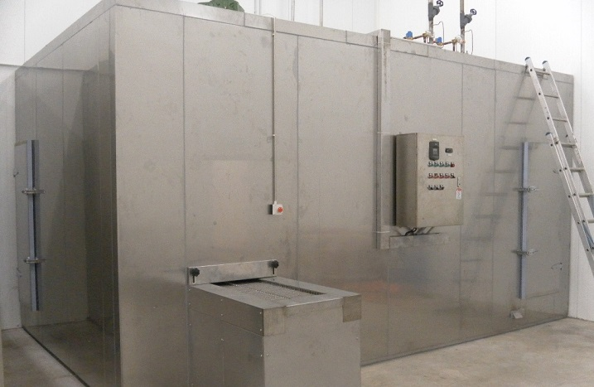 | Capacity : 300kg/h  Installed power: 5.15kw  Refrigeration Consumption: 45kw  Dimension L* W *H: 4.9*4.1*2.5(M)  Belt Width: 450mm
(Spiral)  FSL500 | 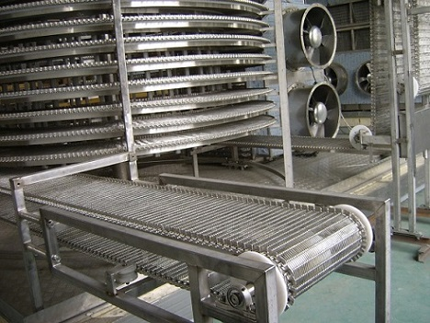 | Capacity : 500kg/h  Installed power: 11.2kw  Refrigeration Consumption: 75kw  Dimension L* W *H: 6.85*5.0*2.9(M)  Belt Width: 500mm
(Spiral)  FSL1000 | 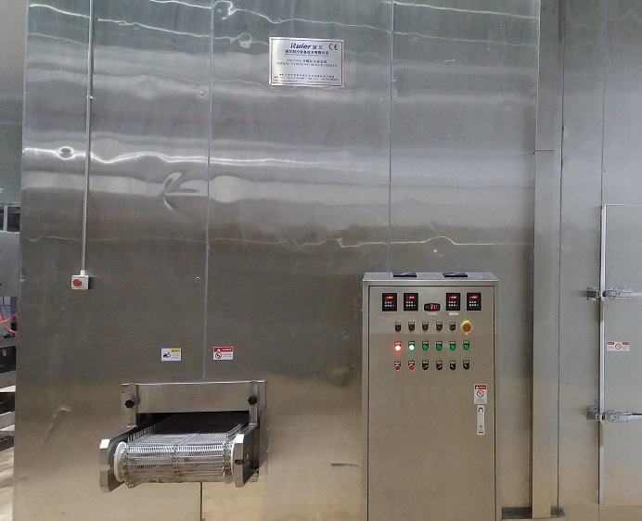 | Capacity : 1000kg/h  Installed power: 22kw  Refrigeration Consumption: 170kw  Dimension L* W *H: 6.8*5.0*3.3(M)  Belt Width: 500mm
(Spiral)  FSL1500 | 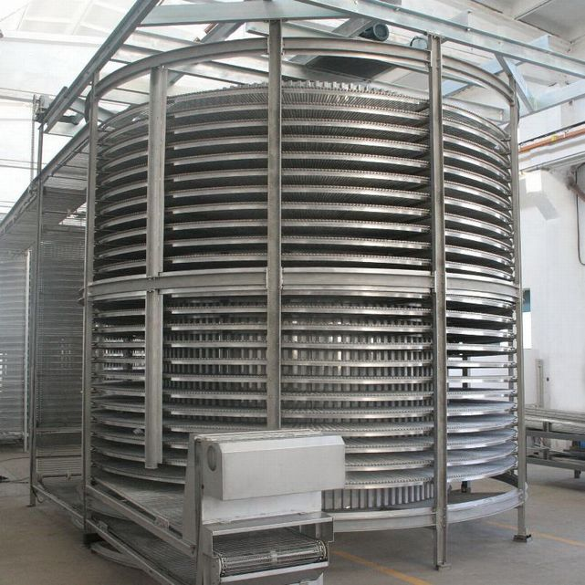 | Capacity : 1500kg/h  Installed power: 31kw  Refrigeration Consumption: 255kw  Dimension L* W *H: 7*5.2*4.5(M)  Belt Width: 600mm

Note : All spiral freezer adopt stainless steel materials .
Can customize according to client details request .
The spiral freezer can adopt Freon or Ammonia system .

