FIRST fresh water flake ice machine price list
Model | Picture (for reference) | parameters | No. | Unit price (EXW) | Remarks
FST-0.2T | 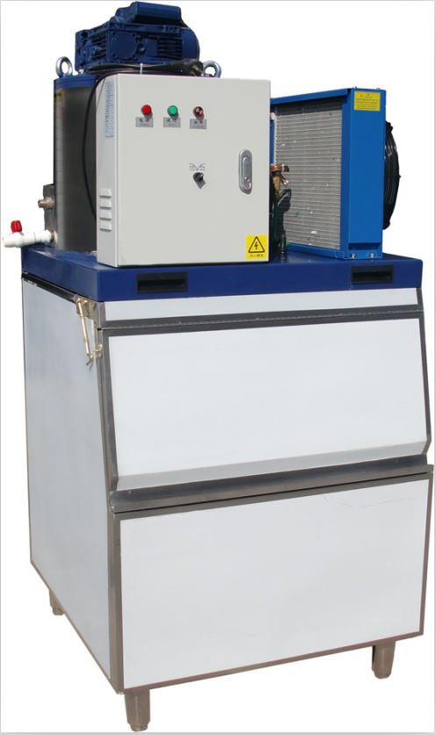 | Ice output：200kg/24hrs  Ice bin capacity：100kg  Compressor：Italy Embraco aspera  Ice machine size：730*760*600mm  Ice bin size：800*760*955mm  Installation space：800*760*1555mm  G.W.：145kg  Standard power supply：1P/220V/50HZ  Total Power：1.1KW  Refrigerating capacity：1.2KW  Refrigerant：R22  Cooling style：Air cooling | 1 | 2,400 | Including ice bin；Standard cooling style
FST-0.5T | 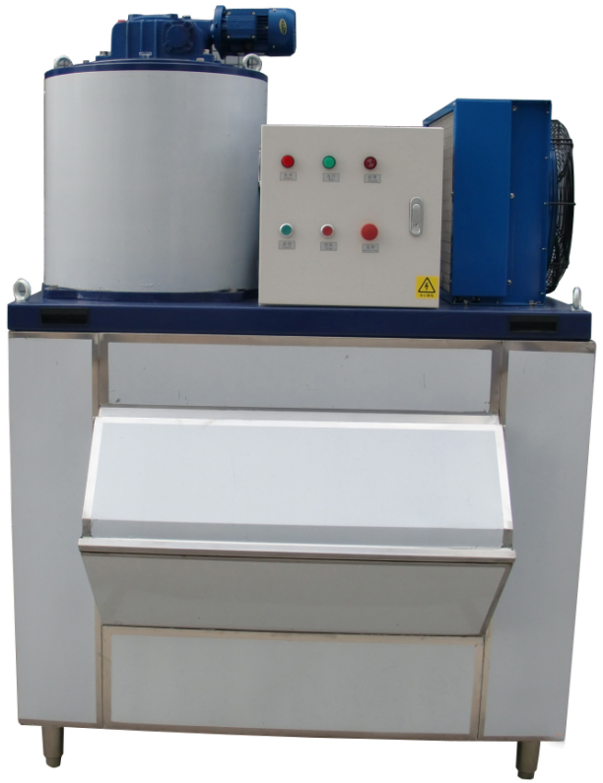 | Ice output：500kg/24hrs  Ice bin capacity：300kg  Compressor：Denmark Daofoss  Ice machine size：1310*890*780mm  Ice bin size：1320*1180*110mm  Installation space：1320*1180*1880mm  G.W.：235kg  Standard power supply：3P/380V 50HZ  Total power：2.62 KW  Refrigerating capacity：3 KW  Refrigerant：R404A  Cooling style：Air cooling | 1 | 3,300 | Including ice bin；Standard cooling style
FST-1T | 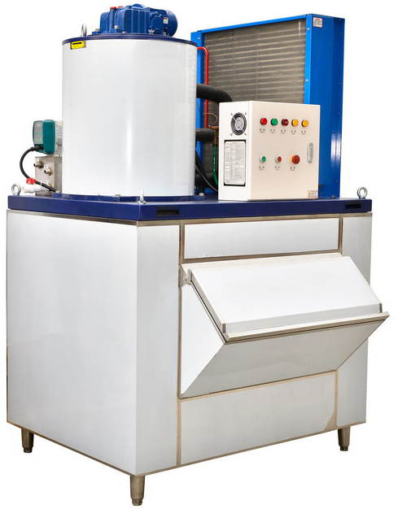 | Ice output：1000kg/24hrs  Ice bin capacity：400kg  Compressor：Denmark Danfoss  Ice machine size：1310*890*880mm  Ice bin size：1320*1250*110mm  Installation space：1320*1250*1980mm  G.W.：270kg  Standard power supply：3P/380V 50HZ  Total power：4.31 KW  Refrigerating capacity：6 KW  Refrigerant：R404A  Cooling type：Air cooling | 1 | 4,100 | Including ice bin；Standard cooling style
FST-1.5T | 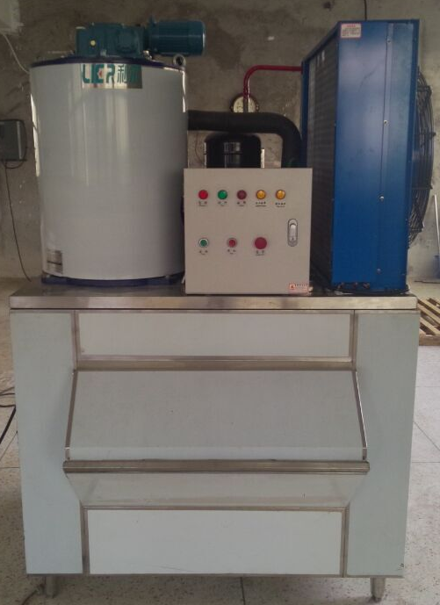 | Ice output：1500kg/24hrs  Ice bin capacity：400kg  Compressor：American Copeland  Ice machine size：1310*890*980mm  Ice bin size：1320*1250*1100mm  Installation space：1320*1250*2080mm  G.W.：390kg  Standard power supply：3P/380V 50HZ  Total power：7.08 KW  Refrigerating capacity：9 KW  Refrigerant：R404A  Cooling type：Air cooling | 1 | 6,100 | Including ice bin；Standard cooling style
FST-2T | 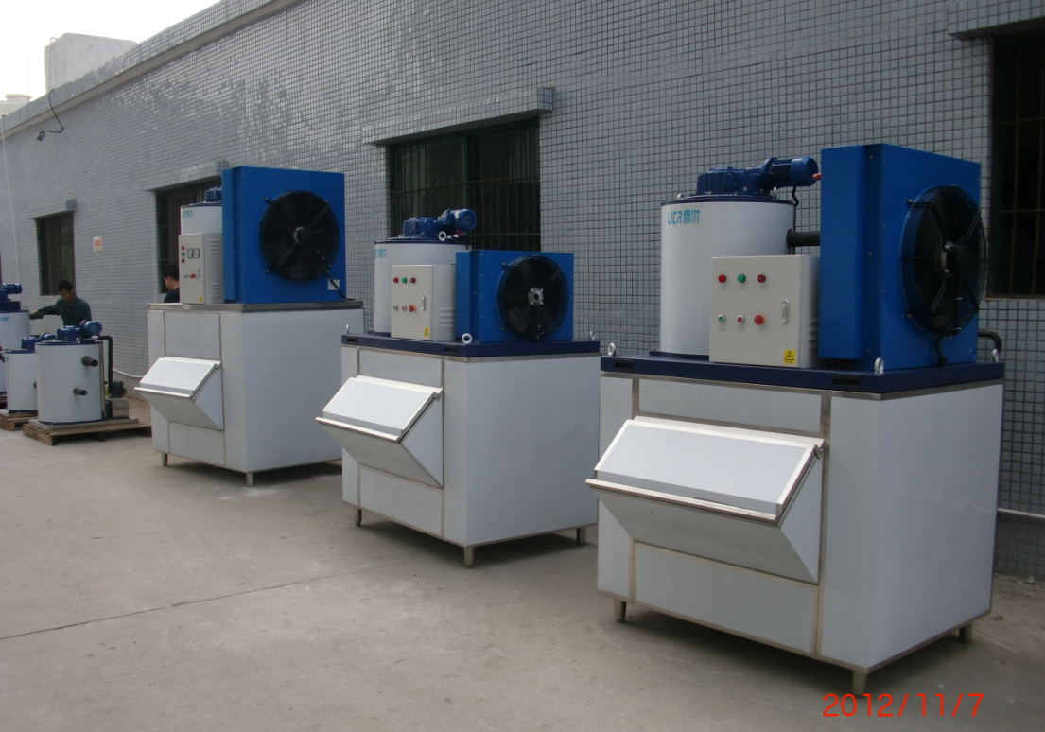 | Ice output：2000kg/24hrs  Ice bin capacity：500kg  Compressor：American Copeland  Ice machine size：1500*1095*1050mm  Ice bin size：1500*1380*1300mm  Installation space：1500*1380*2350mm  G.W.：470kg  Standard power supply：3P/380V 50HZ  Total power：8.6 KW  Refrigerating capacity：12 KW  Refrigerant：R404A  Cooling type：Air cooling | 1 | 6,900 | Including ice bin；Standard cooling style
FST-2.5T |  | Ice output：2500kg/24hrs  Ice bin capacity：500kg  Compressor：American Copeland  Ice machine size：1500*1095*1200mm  Ice bin size：1500*1380*1300mm  Installation space：1500*1380*2500mm  G.W.：520kg  Standard power supply：3P/380V 50HZ  Total power：9.1 KW  Refrigerating capacity：15 KW  Refrigerant：R404A  Cooling type：Air cooling | 1 | 7,700 | Including ice bin；Standard cooling style
FST-3T | 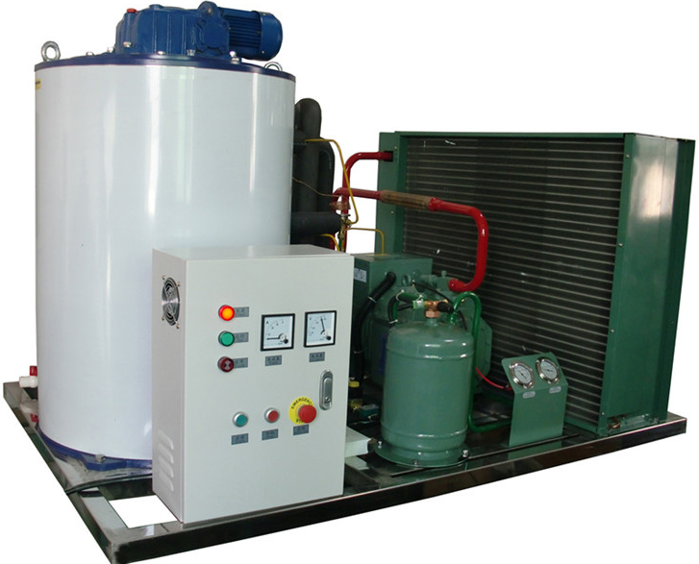 | Ice output：3000kg/24hrs  Compressor：Germany Bitzer  Ice machine size：1750*1190*1200mm  G.W.：530kg  Standard power supply：3P/380V 50HZ  Total power：15.11 KW  Refrigerating capacity：18 KW  Refrigerant：R404A  Cooling style：Air cooling | 1 | 10,600 | Ice storage room is optional according to customers’ request with extra price.  Standard cooling type:Air cooling
FST-5T | 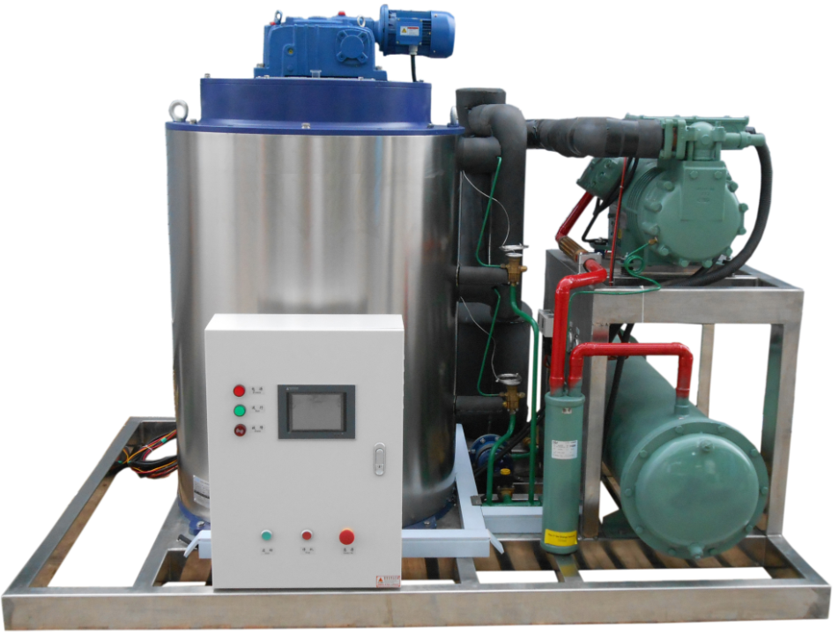 | Ice output：5000kg/24hrs  Compressor：Germany Bitzer  Ice machine size：1750*1550*1600mm  G.W.：765kg  Standard power supply：3P/380V 50HZ  Total power：23.12 KW  Refrigerating capacity：30 KW  Refrigerant：R404A  Cooling type：Water cooling | 1 | 15,500 | Ice storage room is optional according to customers’ request with extra price.  Standard cooling type:water cooling(Equipped with water tower)
FST-8T | 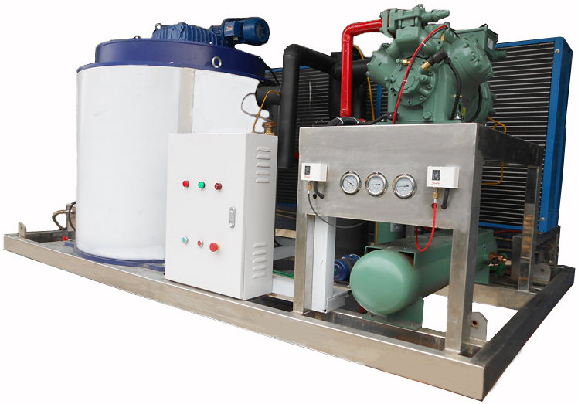 | Ice output：8000kg/24hrs  Compressor：Germany Bitzer  Ice machine size：2530*1830*1680mm  G.W.：978kg  Standard power supply：3P/380V 50HZ  Total power：31.5 KW  Refrigerating capacity：52 KW  Refrigerant：R404A  Cooling type：Air cooling | 1 | 25,600 | Ice storage room is optional according to customers’ request with extra price.  Standard cooling type:water cooling(Equipped with water tower)
FST-10T | 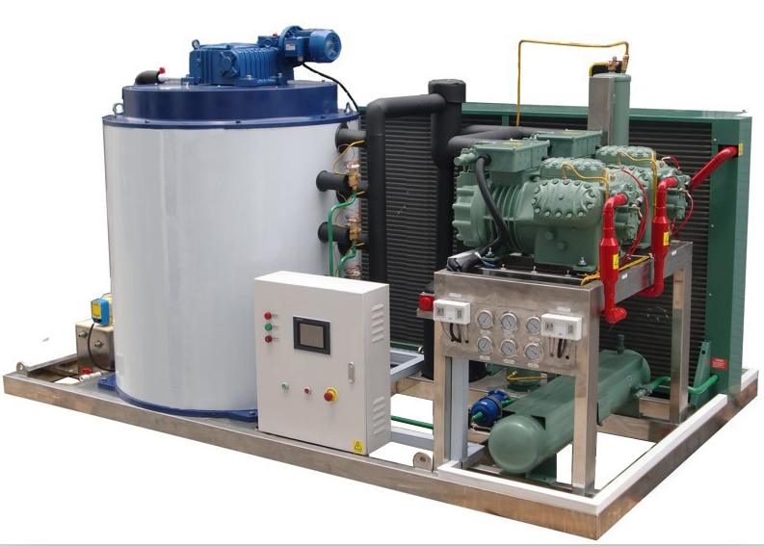 | Ice output：10000kg/24hrs  Compressor：Germany Bitzer(two sets in parallel)  Ice machine size：2530*1830*1820mm  G.W.：1540kg  Standard power supply：3P/380V 50HZ  Total power：45.5 KW  Refrigerating capacity：65 KW  Refrigerant：R404A  Cooling type：Air coog | 1 | 31,100 | Ice storage room is optional according to customers’ request with extra price.  Standard cooling type:water cooling(Equipped with water tower)；Other brand compressor is available for choice with different price:Taiwan Hanbell/Fusheng screw compressor(more economical）;Germany Blogs piston compressor；

